40 Wise Biography

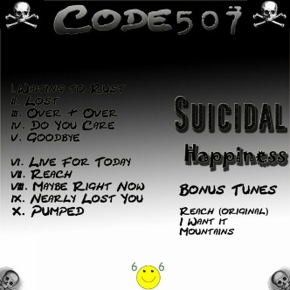 40 Wise consists of two main writers and performers who were born and bred in the Detroit Michigan Metro area. Steven "Chaoz" Edwards and Xzeem began Playing local bars at age 15. Xzeem started his musical quest at age 13 when his mom bought him a guitar. Transferring to the bass Xzeem began playing live shows with numerous bands before spending some years with his first bar band whom he fronted called Outshined. Chaoz began taking his aggression out on the drums at age 15 and learned how to play from drummer extraordinaire Bruce Jensen. Chaoz played in numerous bands and in 1996 formed a bar band with Xzeem and two other players one of them being guitar Phenom Joe Mondrous (R.I.P.). That was the beginning of their musical relationship. In 1998 the two came together to form the band Code507. The duo then wrote and recorded their first album "Suicidal Happiness" which included the ballad "Something She'd Say" and various other rockers such as "Live for Today" in 1999 but never released it due to the scene at the time.

They then formed a band titled Planet 99 with a third individual and recorded a 6 song Live EP that included original material and one blistering cover of the song "Rockin' the Free World" by Neil Young. Unfortunately family life took over for two of the members and again the EP never got released. Hopefully someday these songs will get released due to their musical genius and intensity.

In 2008 the two reformed and recorded a 6 song EP with Killer rock songs "Into the Blue" and "I'm Having Fun". Their best work to date showcased some of their talent as Chaoz mixed and produced this whole EP on an 8 track! Xzeem showcased his musical writing talent and again proved that he can be something big in the music industry.
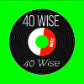 Fast forward to 2020 and the pandemic took over. Xzeem and Chaoz decided it was time to unleash their style of Rock onto the world. Feeling invigorated by the wisdom they learned along the way and Deciding on Carpe Diem the duo seized the moment renewed by a mantra of living and mastered the best works of their prior writing. Combining the two albums solely written by them the album "40 Wise" was released. 40 Wise was coined from the understanding of what time and wisdom can offer.
The next step was Building a studio and forming their own record label. Chaoz and Xzeem knew nothing would be easy but Armed with music in their blood their sophomore album is to be recorded at their studio in early 2021 and to be released later that year! It will be the best of what this duo has to offer and will be aimed at joining the ranks of the greats before them!

We have various files for download. There is a photos Zip file and also a music clip Zip file. This article is also in a word file for your convenience . If you need anything else for radio, promotion, booking, interviews, etc. Please use the contact us form and we will get back to you as quickly as possible.

